Контрольно- измерительные материалы по английскому языку для 5 класса
Входная административная диагностическая работа.
- Choose the odd word:
1. late, difficult, easy, blackboard, big
2. English, P.E., Math, Art, museum
3. pen, rubber, holiday, desk, pencil
4. Monday, Tuesday, April, Friday, Sunday
5. spent, left, met, laughed, learnt

- Choose the right answer:
1. Tom usually _____basketball after school.
- plays b. play c. playing
2. I ______in the lake next summer.
a. swim b. swam c. will swim

3. The children ________at the Zoo yesterday.
a. was b. were c. are

4. His dog is ______than my dog.
a. big b. bigger c. the biggest

5. I think, roses are very ______ flowers.
a. beautiful b. more beautiful c. the most beautiful

6. I have _____little sisters.
a. a b. an c. two

7. Nick is a very good tennis_______.
- play b. playing c. player

- Read the text and mark the sentences T (true) or F (false):
The Vet’s Day
Alex Peterson is a vet. He works in a small town in England. Alex’s day begins very early at six o’clock. He gets up, has a quick breakfast, then gets into his car. In the mornings, he drives around the local farms to check on the animals – cows, sheep and horses. At eleven o’clock, he goes to his surgery in the town. People bring their pets for Alex to look at. Most of the time, they only need an injection or some medicine, but sometimes they need an operation.
Alex usually has lunch – a sandwich – standing up! In the afternoons, Alex often goes to schools in the area to talk to the students about looking after their pets. Alex’s evenings are very quiet. When he gets home, he cooks dinner and usually reads or watches TV. He goes to bed early, ready to face the next busy day. In his free time, Alex likes going to the cinema or taking long walks in the country with his two dogs, Sheba and Nell.

1. Alex gets up at 7 o’clock.
2. After breakfast he goes to the farms to see the animals: cats and dogs.
3. Alex gives the animals some medicine or injections.
4. Alex never has lunch.
5. Alex often tells the students how to take care of their pets.
6. Alex has his dinner at the restaurant.
7. He listens to the radio in the evening.
8. He goes to bed quite early.
9. Alex’s day is very busy.
10. Alex has got two pets.

4.* Make up the sentences:
1. went, year, to Moscow, last, They.

2. sentences, in the lessons, from, Russian, We, translate, English, into.

3. our, visit, next, grandparents, We, summer, will.

Контроль по теме "Моя семья. Мои друзья. Семейные праздники: день рождения, Новый год"
Контроль по теме "Внешность и характер человека (литературного персонажа)"
- Найдите правильный вариант перевода для слов:

good-looking
pretty
attractive
beautiful
handsome
ugly
привлекательный
симпатичный
красивый (о женщине)
хорошо выглядящий
ужасный
красивый (о мужчине)

- Нарисуйте лицо, раскрасьте и опишите внешность человека.
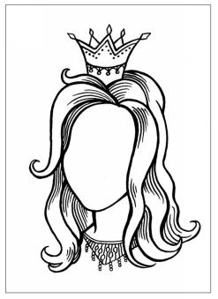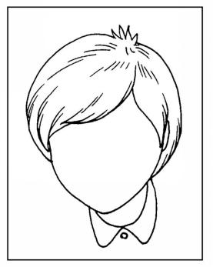

She is _____________ and _______________.
Her face is _____________.
Her hair is __________, ___________, ________.
Her eyes are _______________.
Her nose is _____________.
He is _____________ and _______________.
His face is _____________.
His hair is __________, ___________, ________.
His eyes are _______________.
His nose is _____________.

- Вставьте пропущенные буквы:

Bo_ts, dre_s, j_ans, s_irt, swims_it, p_llover, tr_users
Выберите правильно составленное предложение в Present Simple.
- I do my homework every day.
- I doing my homework every day.
- I have just done my homework.
- Выберите правильно составленное предложение в Present Perfect.
- I do my homework every day.
- I doing my homework every day.
- I have just done my homework.

Контроль по темам "Досуг и увлечения (хобби) современного подростка (чтение, кино, спорт)" и "Здоровый образ жизни: режим труда и отдыха, здоровое питание"
Задание №1
Замените подчеркнутые слова личными местоимениями.
- Jerry and I met Samantha. Samantha gave Jerry and me a letter for you. Take the letter.
- Dan and Mike are leaving for New York. I am driving Dan and Mike to the airport.
- I’m calling Alexander. I haven’t seen Alexander for ages. And Alexander isn’t at school.
- Let’s go to the book shop with Peter and me. Peter and I need some books in Japanese.
Задание №2
Ответьте на следующие вопросы:
- Do you have a hobby?
- What do you usually do in your free time?
- What do you like to do most of all in your free time?
- What do you rarely do in your free time?
- Do you often play with you friends?
Задание №3
Выбери правильную форму глагола TO BE
- What ... you planning to do next summer?
a) am b) is c) are
- I ... reading a letter from my pen-friend Alice.
a) am b) is c) are
- ... he chatting on the internet?
a) am b) is c) are
- Mark and Polly ... flying to the UK.
a) am b) is c) are
- Listen! I ... singing a nice song.
a) am b) is c) are
Задание №4
Вычеркните лишнее слово
- Friendly, independent, kind, responsible.
- Unusual, unlucky, unhappy, athletic.
- Teacher, librarian, firefighter, mother.
- Writing, dancing, dreaming, making.
- Putting, cutting, swimming, walking.
Задание №5
Выберите правильную форму глагола to have (have, has, had)
- My sister … got three dogs.
- We … English three times a week.
- Yesterday I … 5 lessons.

Контроль по теме "Покупки: одежда, обувь и продукты питания"
Task 1. Translate the words and combinations
1. a shoe shop_____________________
2. a record shop ___________________
3. a café __________________
4. a florist`s_____________________
5. a fast food restaurant____________________________________
6. a zoo______________________________
7. a theatre _____________________
8. watch TV____________________
9. play football ____________________
10. surf the Net _________________________

Task 2. Fill in the correct word:
florist`s ● park ● shop ● aspirin ● fantasy ● theatre
- I can see a shoe ……………called Laura`s.
- You can buy some flowers in the …………...
  - What do you want to buy at the chemist`s? – Some …………..
- We watched a play in the ………….. last weekend.
- Let`s go on a roller coaster at an adventure ……………….
- I like Harry Potter`s films, they are ……………..
Task 3. Choose the correct word:
1. You must go to the zoo / art gallery and see wild animals.
2. I`m looking for a teddy / toy train.
3. Let`s go on a roller coaster at the adventure cinema / park.
4. We usually have dinner at the zoo / fast food restaurant.
5. She buys CDs / books at the record shop.

Task 4. Use must / mustn`t
1. You ……………… speak loudly in the museum.
2. You ……………… be quiet in the library.
3. You ……………… run at school.
4. You ……………... eat and drink at the art gallery.

Task 5. Use the verbs in brackets in Past Simple:
1. I ………… (go) to the zoo last week.
2. ………..you ………….(see) a new film with Daniel Radcliff?
3. We ………………. (not watch) TV yesterday.
4. ………..you …………. (finish) your work? No, we …………….
5. They ………….(play) football last summer.
6. - ………….. your sister …………. (visit) Paris last year? – No, she ………… (visit) London.
7. My friends ………………………….. (not surf) the Net yesterday.
Task 6. Put the sentences at this dialogue in right order (1,2,3…..)
A. Thanks a lot.____________
B. Where exactly?_____________
C. Excuse me, is there a toy shop near here?___________
D. Yes, there is on Red Street.___________
E. On the corner of Edison Street and Red Street. ____________

Контроль по теме "Школа, школьная жизнь, школьная форма, изучаемые предметы. Переписка с иностранными сверстниками"

https://media.prosv.ru/content/item/reader/83/ стр 44 аудиозапись

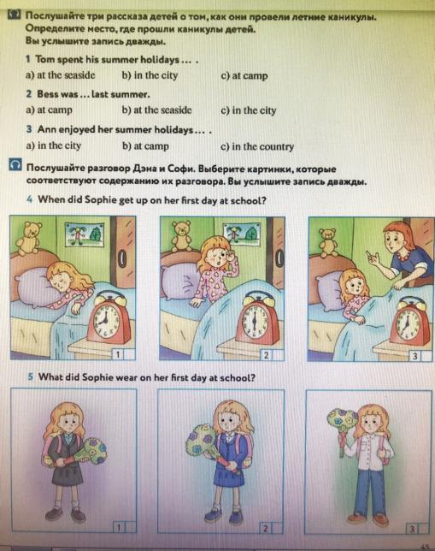

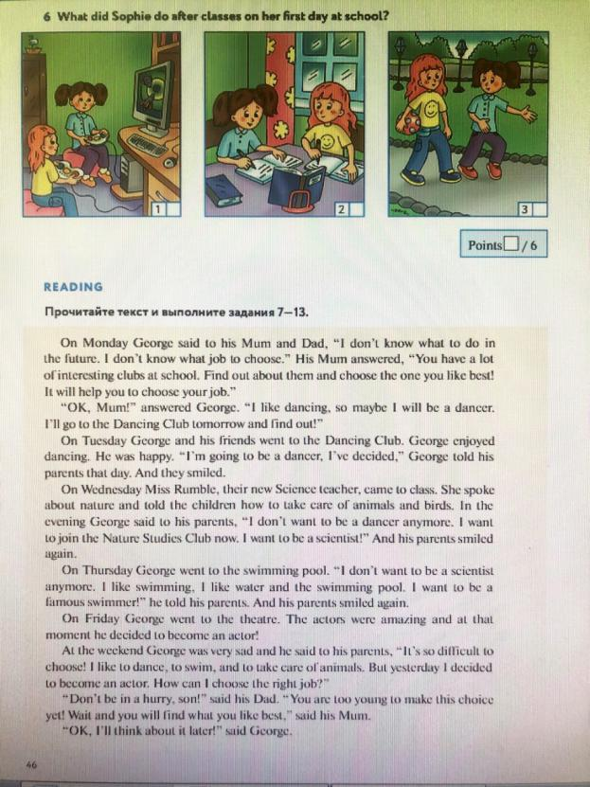

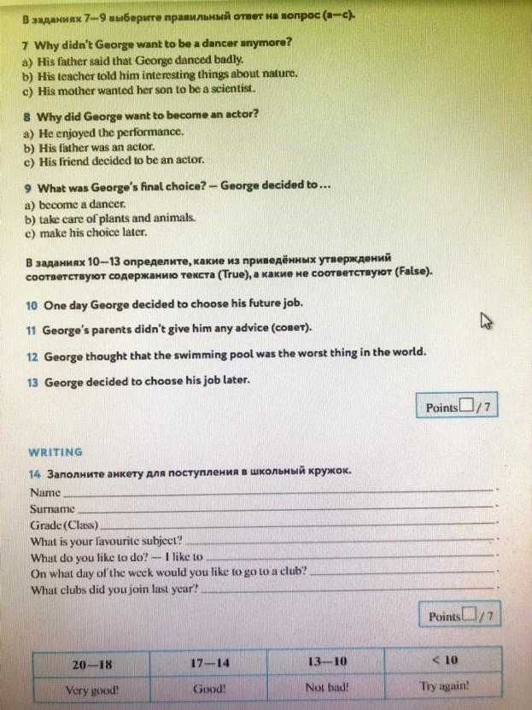

Контроль по теме "Каникулы в различное время года. Виды отдыха"

1,Fill in the gaps with the missing words from the box.

Square, sea, abroad, thing, hotel, capital, city
My cousin had wonderful holidays ___________ last year.
You can see a lot of interesting __________ in England.
When I was in Moscow I saw Red __________.
There are a lot of cars and buses in a big _________.
We stayed in a comfortable __________ when we were in London.
The ___________ of France is Paris.
We went to the _______ last summer.
№2. Match the titles to the paragraphs, one title is extra.
A Holiday at the Sea
Travelling Abroad
Tastes Differ
Camping is the Best Holiday
Summer in the City
Summer Holidays
All the people enjoy summer holidays very much. It is a great pleasure to have a rest after the whole year of hard work or study. People like travelling during their summer holidays. Some people go abroad to see new countries, some people prefer to go to the countryside to enjoy country life far from noise and fuss of big cities.
Some people like spending their holidays in cities, visiting theatres, museums and going sightseeing. Many theatres companies come to Moscow, for example, from other cities. They bring new plays. My friend always spends June and July in the city. There are not so many people in museums or theatres.
I prefer to have a holiday at the seaside. I do not like crowds when I am on holiday. My family and I always have our holiday on the coast. The sea and sunshine that is what we look forward to every summer. Hotels at the large seaside towns are rather expensive, so we usually go to a holiday camp.
Last year we spent our holidays in such a camp. Each day was full of small joys. We swam in the sea, lay in the sun, played different games. We had a wonderful time. The time flew very quickly. It was a wonderful holiday.
1 | 2 | 3 | 4

№3. Match the words and the definitions.
cruise | travelling to watch and take pictures of wild animals
fishing | the activity of swimming under water with a container of air on your back
hiking | travelling on a ship for pleasure and visiting a number of places
safari | travelling across the sea in a boat
sailing | a sport in which you move across water standing on a flat board with a sail that you can move
scuba diving | the activity of walking long distances in the countryside
swimming | the sport of catching fish
windsurfing | moving in the water for pleasure or sport

1 | 2 | 3 | 4 | 5 | 6 | 7 | 8

№4. Complete each sentence with the correct verb form.
John _________ (to play) football yesterday.
Steve and Mark ___________ (not to go) to London in 2015.
I _________ (not to be) at summer camp now. I _______ (to be) at home.
My classmates _______ (to be) at the seaside now.
My parents __________ (not to be) in the mountains last summer. They ________ (to be) abroad.
My friend and I ________ (to be) in town yesterday. We ________ (to be) at the amusement park.
Our granddad ________ (to go) fishing last week.

Контроль по теме "Природа: дикие и домашние животные. Погода"
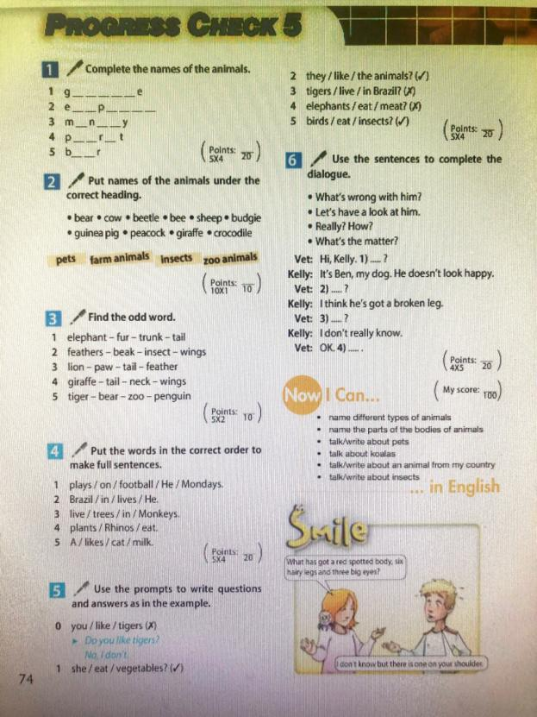

Контроль по теме "Родной город (село). Транспорт"
№ 1. Read the text and mark the sentences with “T” if they are true and with “F” if they are false.
The city and the countryside
Hi. My name`s Jenny. I`m 14 years old. I live in a big city in England. I think life in a big city is fantastic. I have always lots of things to do and there are lots of places to visit. I like going to the theatre or cinema and visiting museums. I love music, so, we go to the concerts with my friends.
One thing I don`t like about the city is the transport. There are always lots of cars and buses.
My best friend Daniel lives in a small village. Daniel thinks life in the country is very nice. There is no traffic.
It is quiet and peaceful in the countryside. There are a lot of trees around. You can see wonderful flowers everywhere. There is a beautiful lake and a wonderful forest. He usually goes swimming in the lake.
Daniel often visits me. We do a lot of things together. We often go to the cinema or swimming in a fantastic swimming pool.
I often visit Daniel too. Then we like walking in the forest or swimming in the lake.

I. TRUE OR FALSE
1. Jenny likes living in the city. _____
2. She doesn`t like cinema or theatre. _____
3. Jenny goes to the concerts with parents. _____
4. Jenny and Daniel do a lot of things together. _____
5. Jenny and Daniel like swimming in the sea. _____

№ 2. Read the letter and fill in the gaps with the words from the box.
beautiful, write, in the country, behind, mountains, garden, swim, apple, river.

Dear Alex,
Thank you for your letter. I am Vova. I am from Russia. My country is large and _______________________. There are many cities and towns in Russia. But I live _____________________________. I live with my mum and dad. Our house isn’t big. There is a green _____________ with ______________ trees and flowers ___________ my house. There is a river next to the forest. My friend and I ________ there in summer. There is an old bridge over the ______________. We’ve got a cow, five sheep, a horse, a dog and a cat. I like to read books about seas, oceans, _____________ and deserts.
______________ me about your country and your town, please.
Your pen friend,
Vova

№ 3. Choose the correct verb form and underline it.
Ann and David are/am staying in London now.
Dennis is/are asking the way to the museum.
Ann and her friends are/is walking in the park.
Ann am/is telling her friends about this park.
David are/is asking questions about statue.
Dennis is/are taking photos at the moment.
№ 4. Make up sentences and questions.
There / beautiful / some / are / parks / my / city / in. _____________________________________________________________
any / Are / zoos / city / in / your / there? _____________________________________________________________
there / any / museums / Are / near / house / your? _____________________________________________________________
There / some / near / are / museums / house / my. _____________________________________________________________
There / any / are / rivers / in / my / village. _____________________________________________________________
Итоговая административная диагностическая работа.
- Поставьте правильные формы Present Simple в пропуски:
do/does/don’t /doesn’t

a).……..you need my book?
b). …… a lion eat leaves?
c) .……. Helen take the bus?
d) She ………..like to sing.

- Вычеркните лишнее слово из логического ряда:

a) Maths, Science, Thursday, Physical Education, Technology
b) sharpener, notebook, pencil case, umbrella, ruler
c) bathroom, bedroom, living room, kitchen, furniture
d) budgie, tortoise, cat, goat, guinea pig

- Соотнесите страну и национальность, ответы запишите ключом:

- the UK | - Italian
- the USA | - Russian
- Canada | - French
- Australia | - English
- France | - Canadien
- Japan | - American
- Italy | - Australian
- Russia | - British
- England | - Japanese

4. Образуйте множественное число существительных: doll
boy
watch
ball
glass
lady
woman
child
window
5. Выберите правильное местоимение, ответы запишите ключом
a) This is my brother. Look at …..(he/him)
b) Susan is my best friend. I can tell …..all my secrets. (she/her)
c) ….. grandpa is very funny.(my/me)

6. Выберите правильную временную форму, ответы запишите ключом:
a) Lara always ….at 7 o’clock. (get up, gets up, got up)
b) Look! He ….a car. (repairs, repair, is repairing)
c) Dolphins ….with one eye open. (sleeps/sleep/is sleeping)
d) I often …..for a walk. (go/goes/am going)
e) Bill ….TV every evening. (watch/watches/is watching)
f) What …..she doing? (does/is/ can)
g) Dennis can sing but he…..draw. (isn’t/can’t/ can)
h) There’s a sofa in my room but there …..any chairs. (isn’t/aren’t/ are)
i) How often … they swim? (have/do/are)
j) Linn usually ….up at 7 o’ clock. (wakes/wake/ woke)

7. Образуйте время Present Continious (настоящее продолженное) c помощью глаголов в скобках.
a) He …………..a newspaper now. (read)
b) They ……………….flowers in the garden. (plant)
c) I ……………..to music at the moment. (listen)

8. Выберите правильное слово, ответ запишите ключом.
- a\some carrots
- a\an apple
- a\some pineapples
- a\some bread
- a\some juice
- a\an tomatoes

9. Напишите названия профессий.
- school –
- taxi –
- post office –
- hospital –
- bakery –
- garage –

10. Read «Emus». Answer questions. Прочитайте текст. Ответьте на вопросы.
Emus are very large birds. They live in Australia. They are very tall. They can’t fly but they can run very fast. They live for nearly 30 years. They eat leaves, fruit and insects and they drink a lot of water. They also like sitting in the mud.

a) Where do emus live?
b) How many years do they live?
c) What do they eat and drink?
d) What do they like?

Контроль по теме "Родная страна и страна (страны) изучаемого языка. Их географическое положение, столицы, достопримечательности, культурные особенности (национальные праздники, традиции, обычаи)"
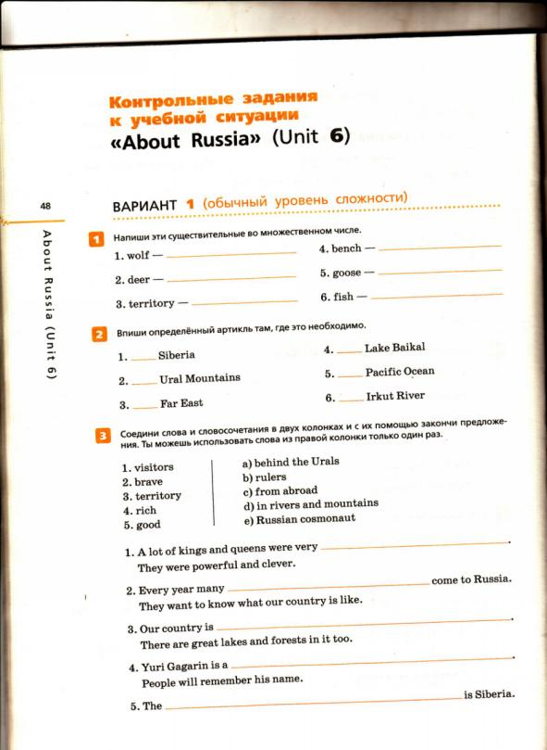

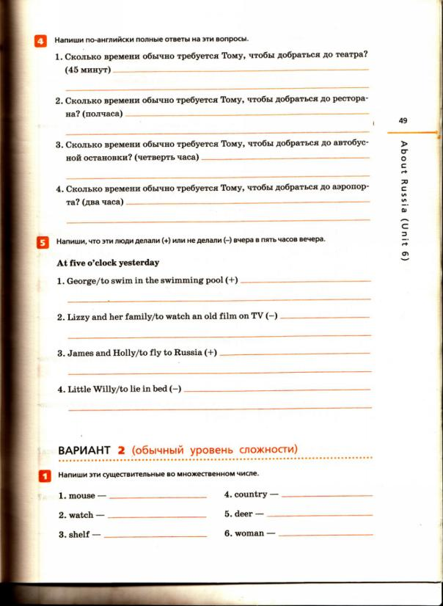

Контроль по теме "Выдающиеся люди родной страны и страны (стран) изучаемого языка: писатели, поэты"
Аудио : https://rosuchebnik.ru/kompleks/rainbow/audio/uchebnik5-1/
